Potential Social Media Posts

Instructions: Use each photo and caption for future social media posts. Save the photo on the left and copy and paste the caption on the right into Facebook, Instagram or your preferred social media platform.

Post 1:  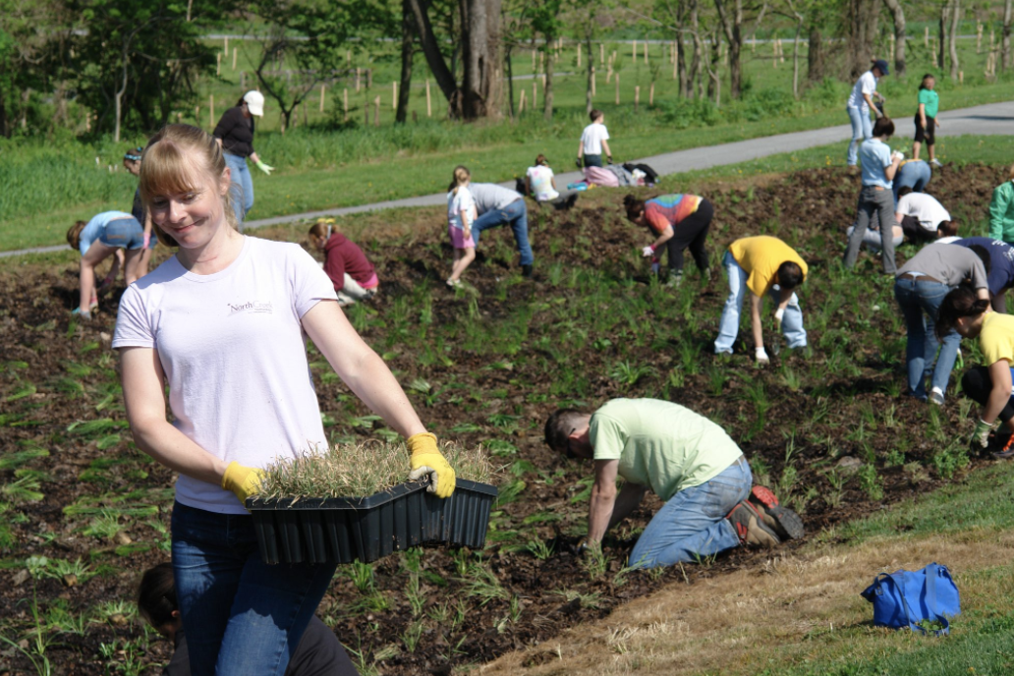 | Post 1 caption:  Want to manage stormwater runoff, reduce flooding, and support biodiversity on your property? Try Planting a Rain Garden!  Rain gardens are similar to ordinary gardens — except they’re dug deeper to allow water to infiltrate before running off untreated to a local waterway. They act as a sponge to soak up excess water in your yard during rain events.  To find out more, visit https://cwmp.org/homeowner_resources/ or download this free app for tips on how to plant rain gardens! https://apps.apple.com/us/app/rain-garden/id588712983
Post 2:  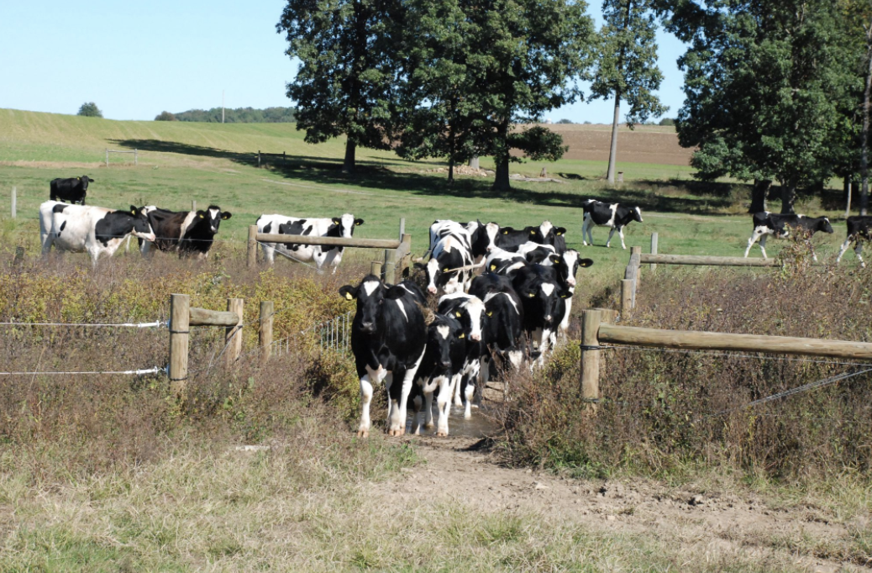 | Post 2 Caption:  Attention all farmers!  ____  Check out : A Farmer’s Guide for Healthy Communities to learn more about what you can do to help to ensure clean water and healthy watersheds.  Also, check out www.cwmp.org/farmer_resources
Post 3:  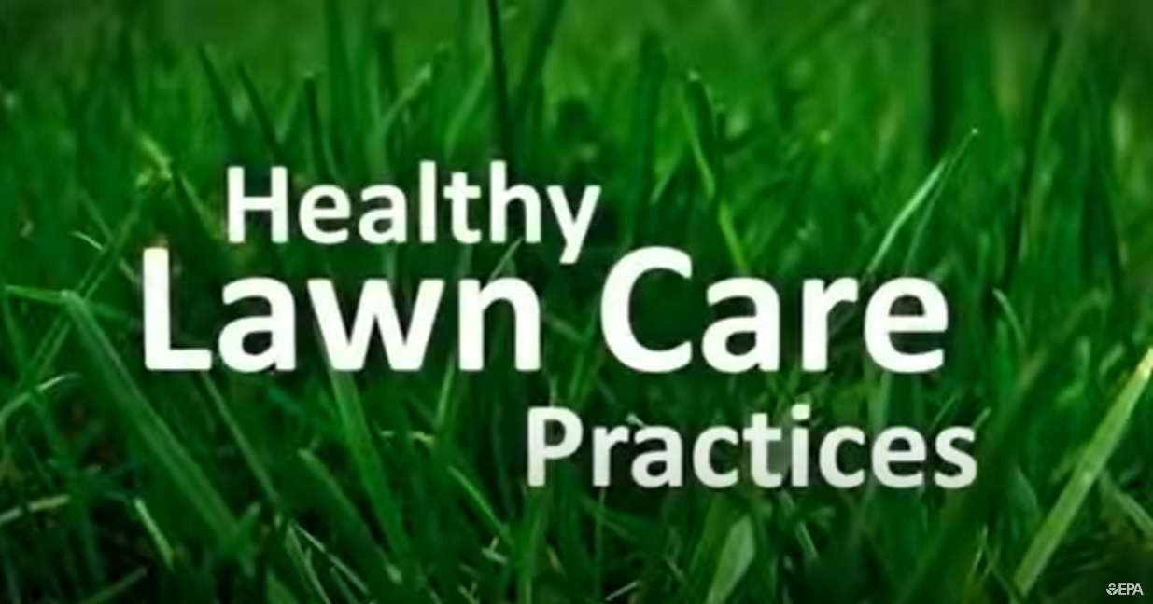 | Post 3 Caption:  Be fertilizer and pesticide smart!  Check out this video with tips on greenscaping and how to keep your lawn environmentally friendly!  https://www.youtube.com/watch?v=who0nxEL5b4
Post 4:  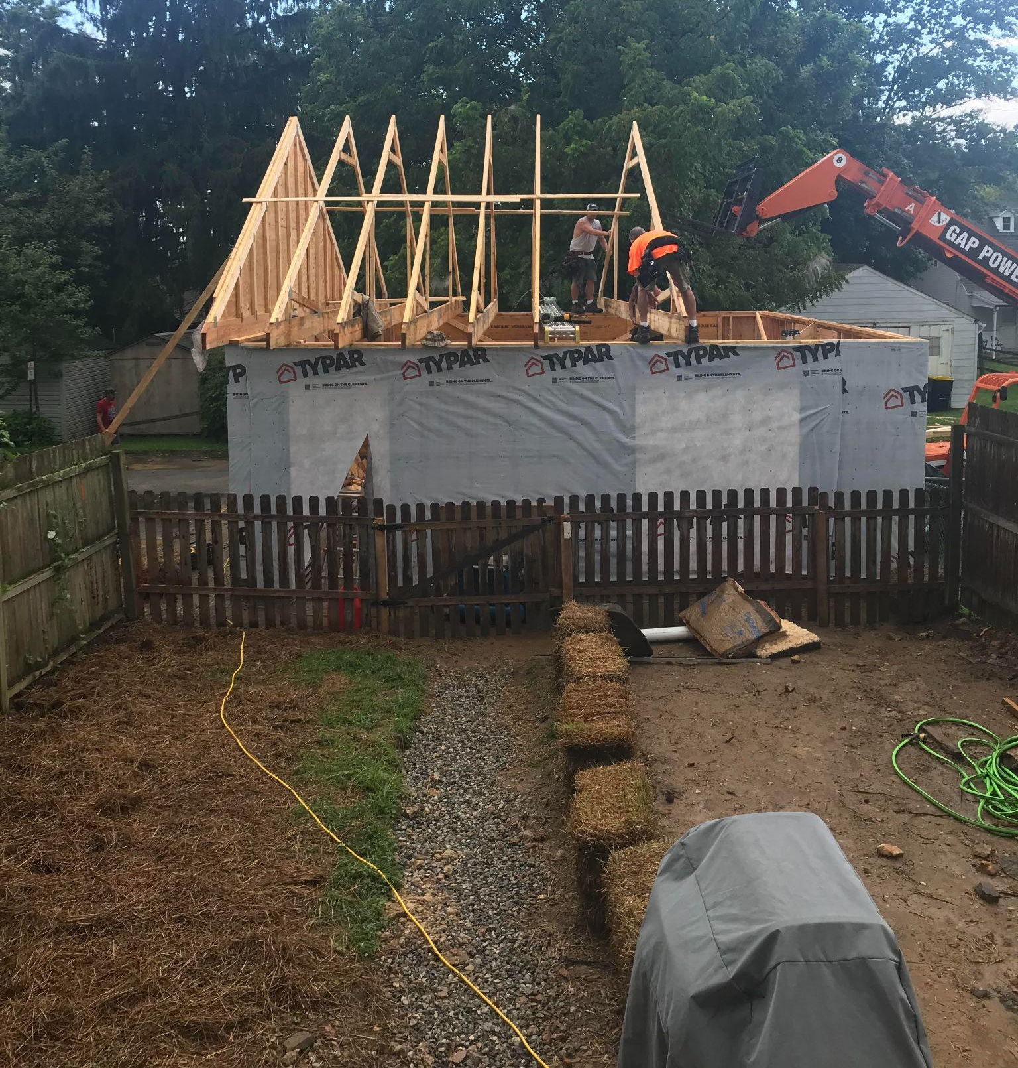 | Post 4 caption:  Thinking about remodeling your home?  Learn about stormwater requirements and best stormwater management practices to help protect your local streams.  https://cwmp.org/developer_resources/
Post 5:  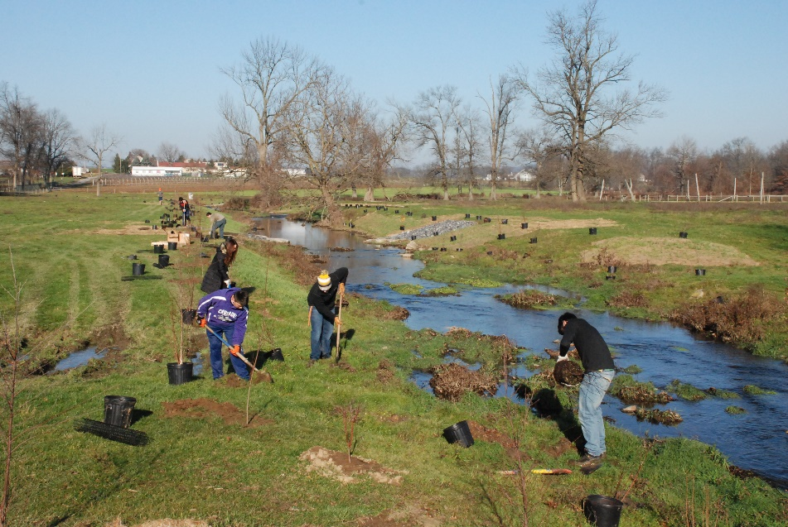 | Post 5 caption:  Plant Trees for Clean Water!  Planting trees has been shown to not only reduce stormwater runoff, but also to reduce steam temperatures, improve air quality, sequester carbon, and add value to a property or neighborhood.  If you are thinking about planting trees around your home check out,  www.cwmp.org/homeowner_resources

